PERSONAL INFORMATION

Full Name: | Date of Birth:

Address:

Postcode:
Telephone: | Mobile: □ tick if we may send you text reminders for future appointments
Email:  tick if you would like to receive our e-newsletter (approx every 2 months) | Occupation:

MEDICAL HISTORY

 | NO | YES | FURTHER INFO
Are you currently seeing a doctor for any medical condition?
Are you taking any medication?
Do you take warfarin or aspirin?
Have you ever taken Roaccutane (acne treatment)?
Do you have any allergies?
Do you have a history of cold sores or lip herpes?
Are you pregnant or breast-feeding?
Have you had cosmetic surgery?
Have you had cosmetic treatment (inc. Botox/fillers)?

AESTHETIC SELF-ASSESSMENT

When I look in the mirror, I believe I look (please circle) | YOUNGER  THAN I AM | THE AGE  I AM | OLDER  THAN I AM
When you look in the mirror how concerned are you about wrinkles? | NOT CONCERNED | SOMEWHAT CONCERNED | VERY CONCERNED

Please tick (below) all the concerns/treatment of interest below |  |  |  | Please mark any specific areas
 | Lines and wrinkles |  | Liver spots/age spots | 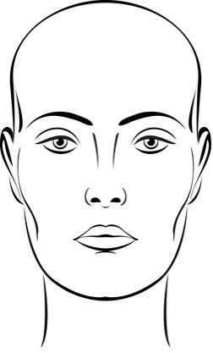
 | Forehead |  | Hands
 | Frown |  | Thread veins – face
 | Crow’s feet / laughter lines |  | Acne
 | Tired look |  | Acne scarring
 | Loss of fullness in the cheeks/temples |  | Saggy jawline/loose jowls
 | Nose shape |  | Skincare advice/products
 | Lip shape/fullness |  | Neck or décolletage
 | Lip-lines/smoker’s lines |  | Hair removal
 | Mouth corners |  | Localised fat reduction
 | Red or blotchy skin |  | Excessive perspiration

How did you hear about us?
 | Website |  | Doctor/GP |  | Advert
 | Friend/relation (name?) |  | Other (if so where?)

Why did you choose Mulberry House Clinic & Laser Centre?

Signature: | Date:

